A simple strategy based on fibers coated with surfactant-functionalized multiwalled carbon nanotubes to improve the properties of solid-phase microextraction of phenols in aqueous solution

Supplementary material

1 Experimental method
1.1 Surfactant functionalized MWCNTs
Firstly, 2 g of pristine multi-walled carbon nanotubes powder was added in a 100mL mixture of HNO₃ and H₂SO₄ (V/V = 1:3) in a water bath at 80 °C for 6h with stirring. The processed MWCNTs were gathered by filtration and washed with deionized water until the final pH approached neutral. Secondly, the processed MWCNTs were modified respectively by cetyl pyridinium chloride monohydrate (CPC), sodium deoxycholic acid (NaDC), polyethylene glycol octyl phenyl ether(tritonx-100), with a mass ratio of 1:1. Table S1 shows the structure and manufacturer of three surfactants. Surfactant/MWCNTs suspension was prepared according to table S2, and the suspension was ultrasonic for 30 min in the ultrasonic crushing instrument, and then by magnetic stirring for 12h. Finally, the above solution was centrifuged at a centrifuge of 7500 RPM for 30 min, and the precipitation was collected and dried for 24 hours at 60°C to obtain the surfactant/MWCNTs powder.

Table S1 The structure and manufacturer of the three types of surfactant
Surfactant | Structure | content | manufacturer
NaDC | 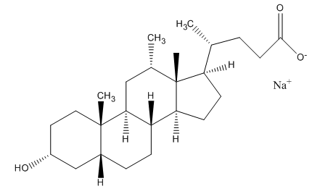 | 99% | Aladdin Chemistry
CPC | 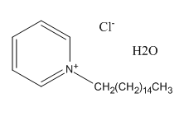 | 99% | Aladdin Chemistry
Triton-100 | 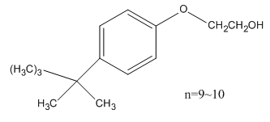 | AR | Tianjin dengfeng chemicals Co.

Table S2 Preparation of the surfactants/MWCNTs solution
Surfactants | Surfactant type | CMC | Surfactant weight | MWCNTs weight | Water volume
NaDC | Anionic | 6×10⁻³ | 2g | 2g | 10mL
CPC | Cationic | 9×10⁻⁴ | 1g | 1g | 10mL
Triton-100 | Nonionic | 2×10⁻⁴ | 2g | 2g | 10mL
CMC is the critical micelle concentration of surfactant.

1.2 Characterization of functionalized MWCNTs
Figure S1 was TEM image of the Original MWCNTs and the functionalized MWCNTs after processing with surfactants. The functionalized MWCNTs with NaDC(Figure S1d) were more hydrophilic than their pristine MWCNTs (Figure S1a) and the other two surfactants processing(Figure S1b and Figure S1c), and showed a better dispersibility structure. This proved that the surfactant be successfully adsorbed on the surface of MWCNTs, the aggregations of MWCNTs were decreased. MWCNTs/ NaDC looks more porous and dispersed (Figure S1d)).

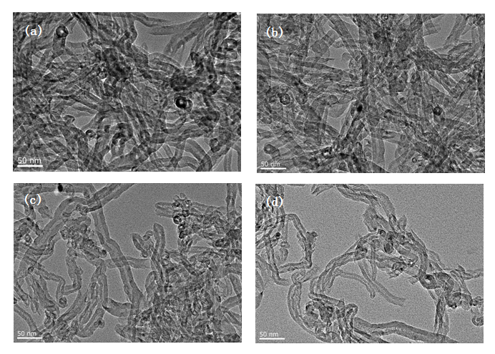
Figure S1 TEM image of the Original MWCNTs (a), the MWCNTs after processing CPC (b), the MWCNTs after processing with tritonx-100 (c), and the MWCNTs after processing with NaDC(d).

